**Recommended actions for future improvements**

**Introduction -**

This report will demonstrate reflection and engagement in the resource process leading to recommended actions for future improvement of the project outcomes. It will also reflect on the success of the research project and the performance at the end of the project with the inclusion of a project evaluation and recommendations.

**Topic -**

***“Are technology companies responsible for the health, safety and wellbeing of users?”***

**Resource used to take recommended actions -**

Here are a few recommended actions based on my research and what possible methods that can be used to be adopted to improve it to be more effective in understanding the issue.

**Increase digital wellbeing health -**

The recommendation I would give based on the above primary and secondary research performed would be that digital wellbeing is growing more and more as users spend more time on their devices and seek for help to stay in control of their health.

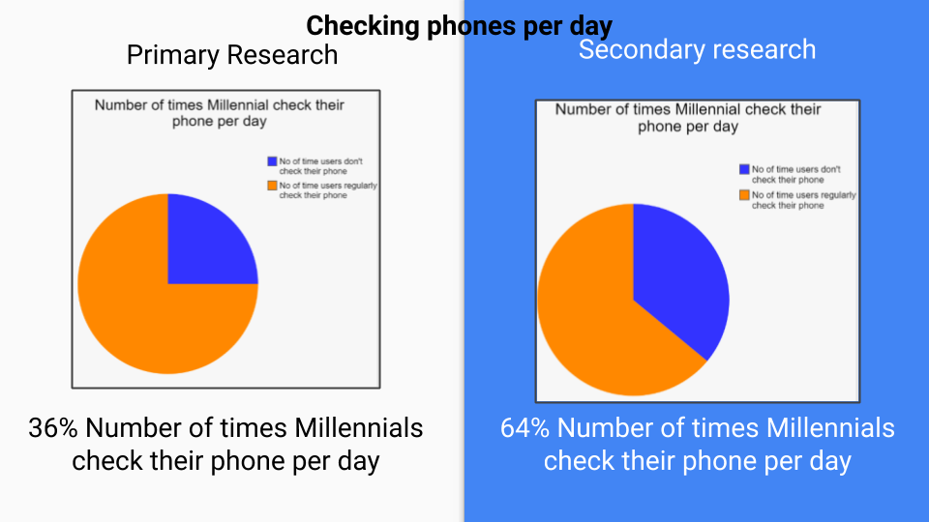

**Safety Precautions -**

Users should stay in control by implementing strict rules to follow to reduce the amount they spend on devices and find other things to distract them from their addictions and find new hobbies that they like.

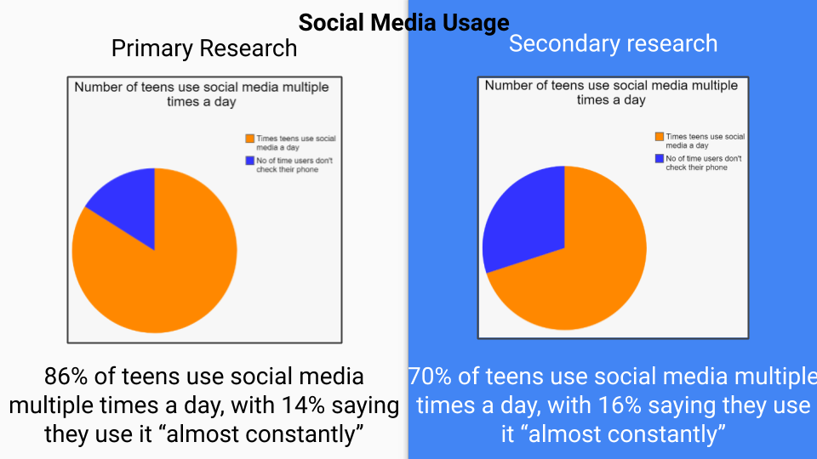

**Change in lifestyle -**

Taking a break would greatly improve their lifestyle and motivate them to go outside and make meaningful relationships and conversations which would otherwise not be possible.

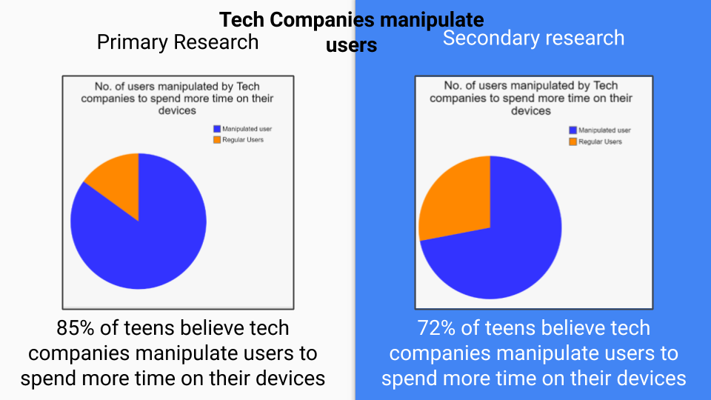

**Making a schedule and changing habits -**

Users must take the first step in making a change in their daily habits by joining groups that move away from digital distractions and find other ways to interact with people.

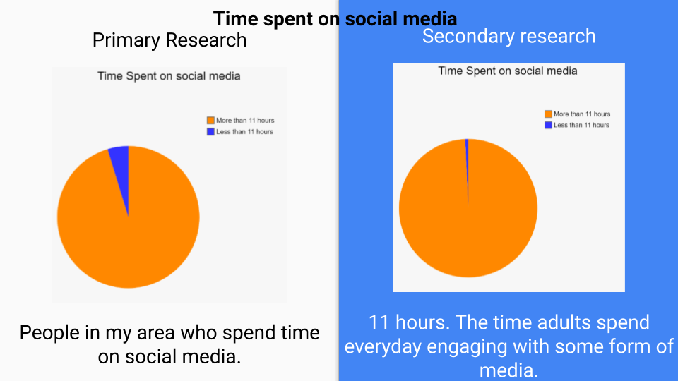

**Recommended actions based on my primary research -**

Here are a few recommended actions based on my primary research and what possible methods that can be used to be adopted to improve it to be more effective in understanding the issue.

**Primary Research -**

The statistical graph shows the numbers of users from my local area from different age groups and how much time users have spent on their devices for the year 2020.

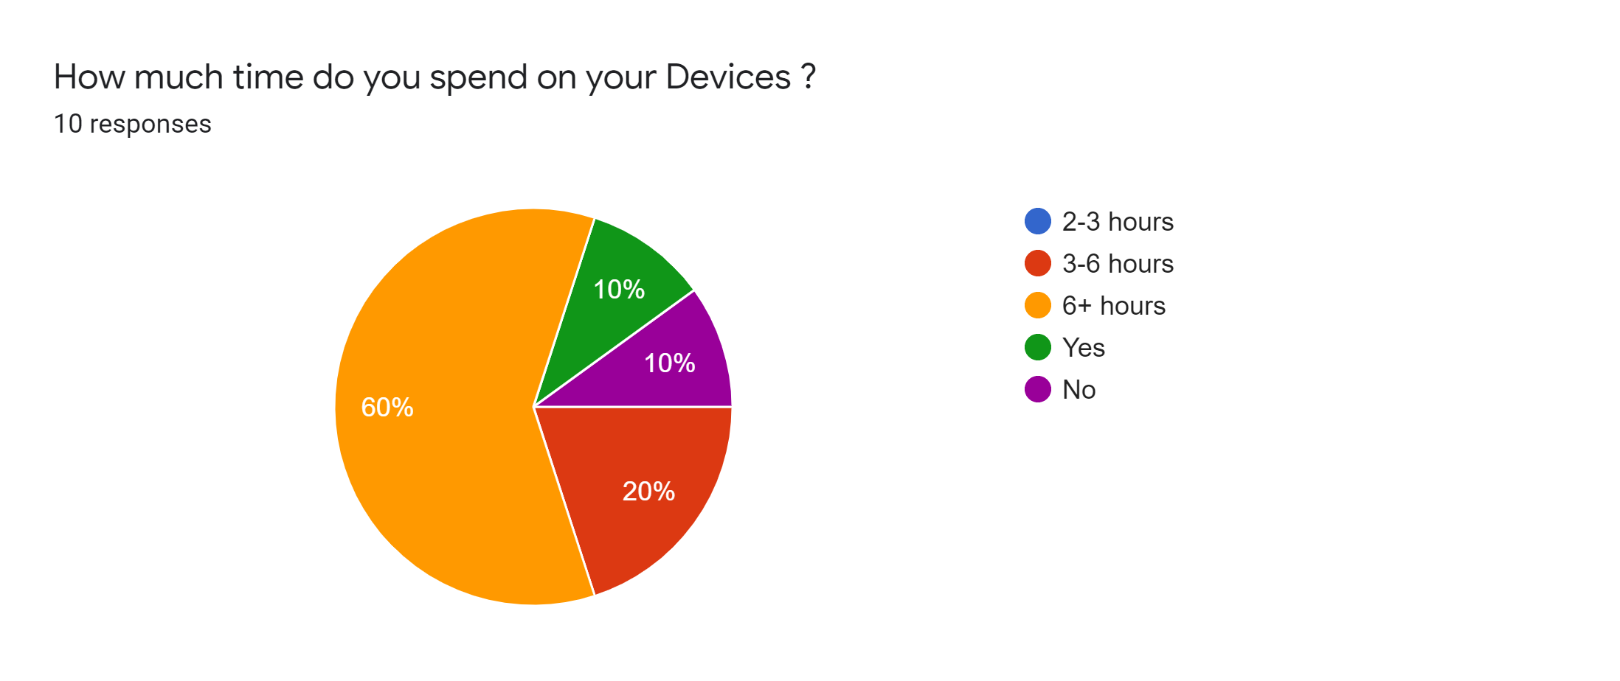

**Finding a inspiration -**

While performing primary research have come across most participants who have come forward admitted to being really attached to their devices whether it be phones, Playstations Consoles, Tablets, IPads, Laptops/PCs and whatever devices are available to the public’s disposal.

This has given an insight on the area and has raised awareness which lead to a solution that can benefit all the participants facing addiction by finding something that inspires your interests and gets you motivated to work towards .

**Primary Research -**

The statistical graph shows the numbers of users from my local area from different age groups who have access to devices for the year 2020.

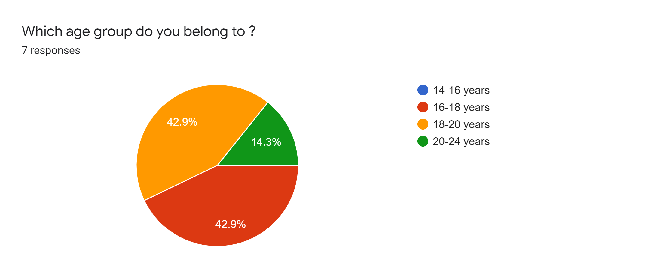

**Meditation exercises -**

According to my primary research participants have also reported that they are unable to focus on their daily tasks while being distracted by their devices.

My recommendation would be to try meditation and find peace within by distancing from distraction such as devices and technology altogether. Making your mind relaxed can help improve your fluids flowing and improve your focusing.

**Primary Research -**

The statistical graph shows the numbers of users from my local area from different age groups and how many devices users use for the year 2020.

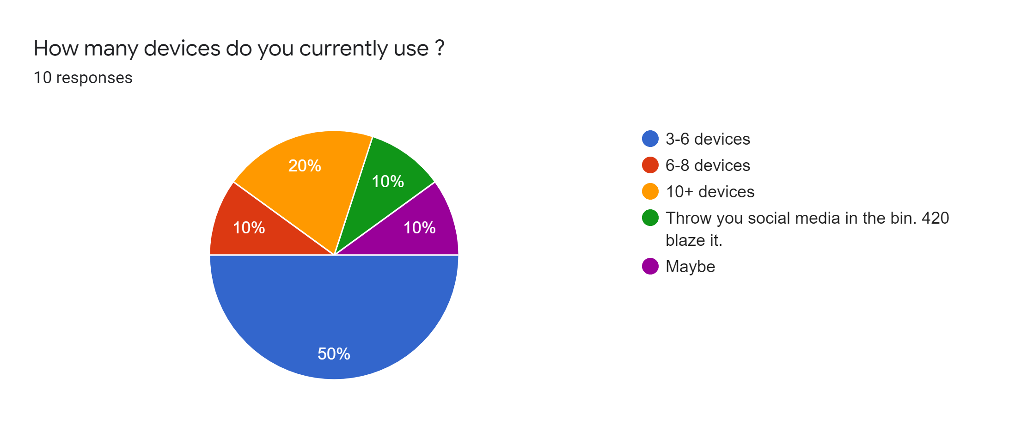

**Making your own research from media data -**

According to my primary research participants have also admitted that they have been influenced by the media and have presented news and other social occurrences which affected the mental health of participants. This would lead to stress and anxiety attacks and bring confidence down which is not ideal for mental health.

To overcome this type of mental health issues one should not take any information off the internet seriously as they may be fabricated to influence individuals. Instead do your own research and make your own conclusion by rationalising what is portrayed by the public media.

**Coping with Unhealthy behaviours -**

Participants have also reported unhealthy behaviors due to digital addiction. With digital wellbeing making sure people are struggling to cope with their mental health it is suggested that individuals try to reduce the amount of time spent on devices, find other things to occupy themselves with or find a hobby they would enjoy.

**Primary Research -**

The statistical graph shows the numbers of users from my local area from different age groups and how devices affect user’s daily tasks for the year 2020.

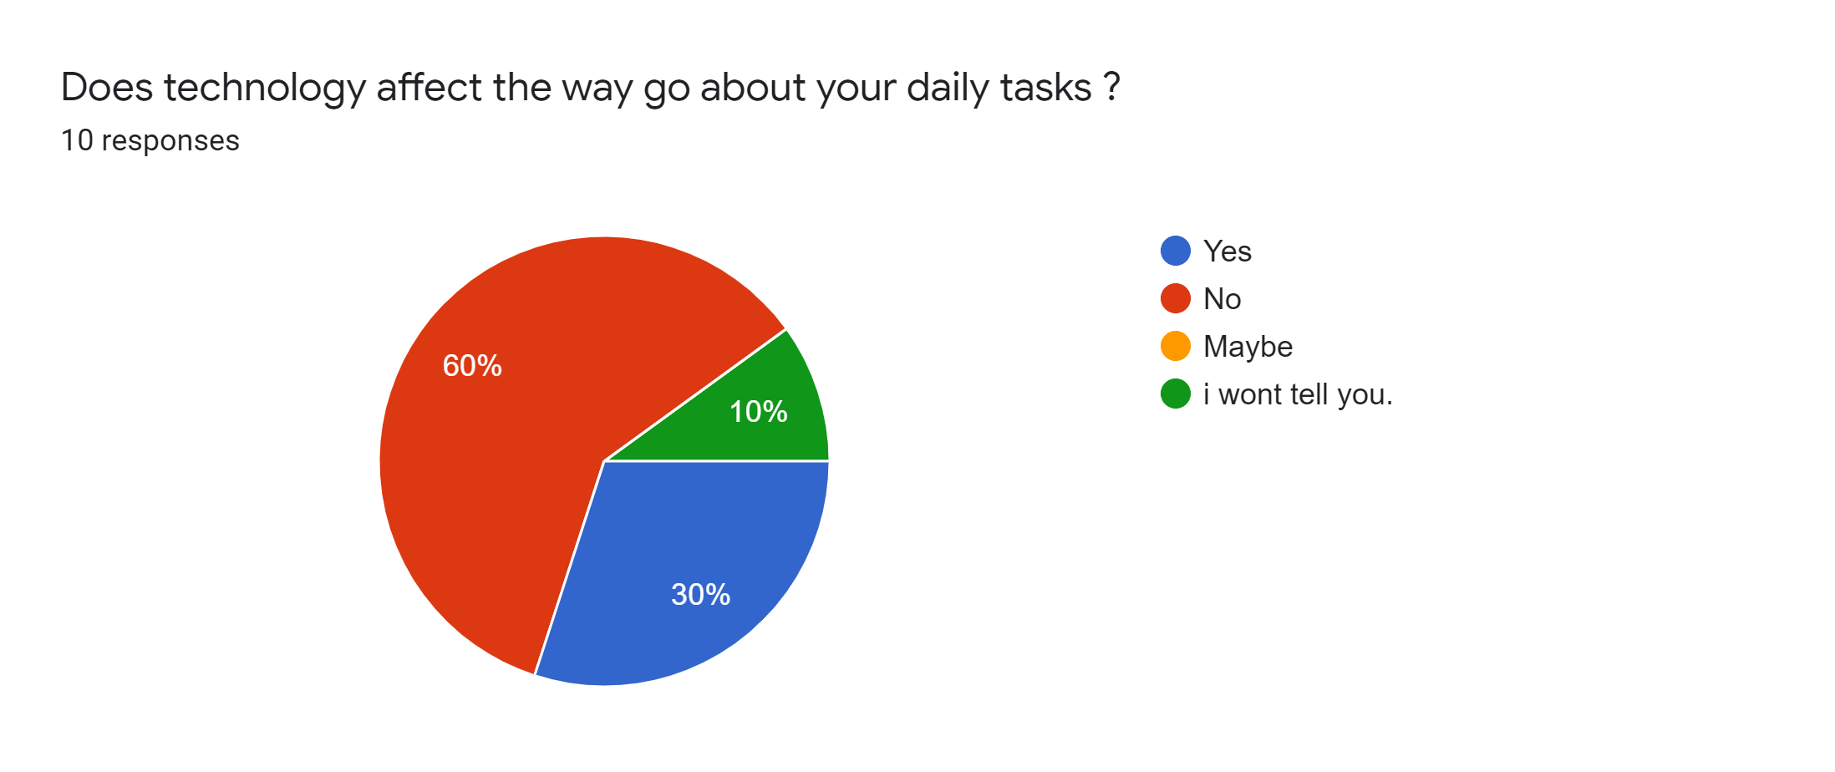

**Seeking for help online -**

As digital wellbeing is growing more and more as users spend more time on their devices and seek help to stay in control of their health whether it be through online group sessions or seeking therapy by joining mental health institutions that would provide the necessary help that is needed.

**Primary Research -**

The statistical graph shows the numbers of users from my local area about if users trust social media companies with their personal information for the year 2020.

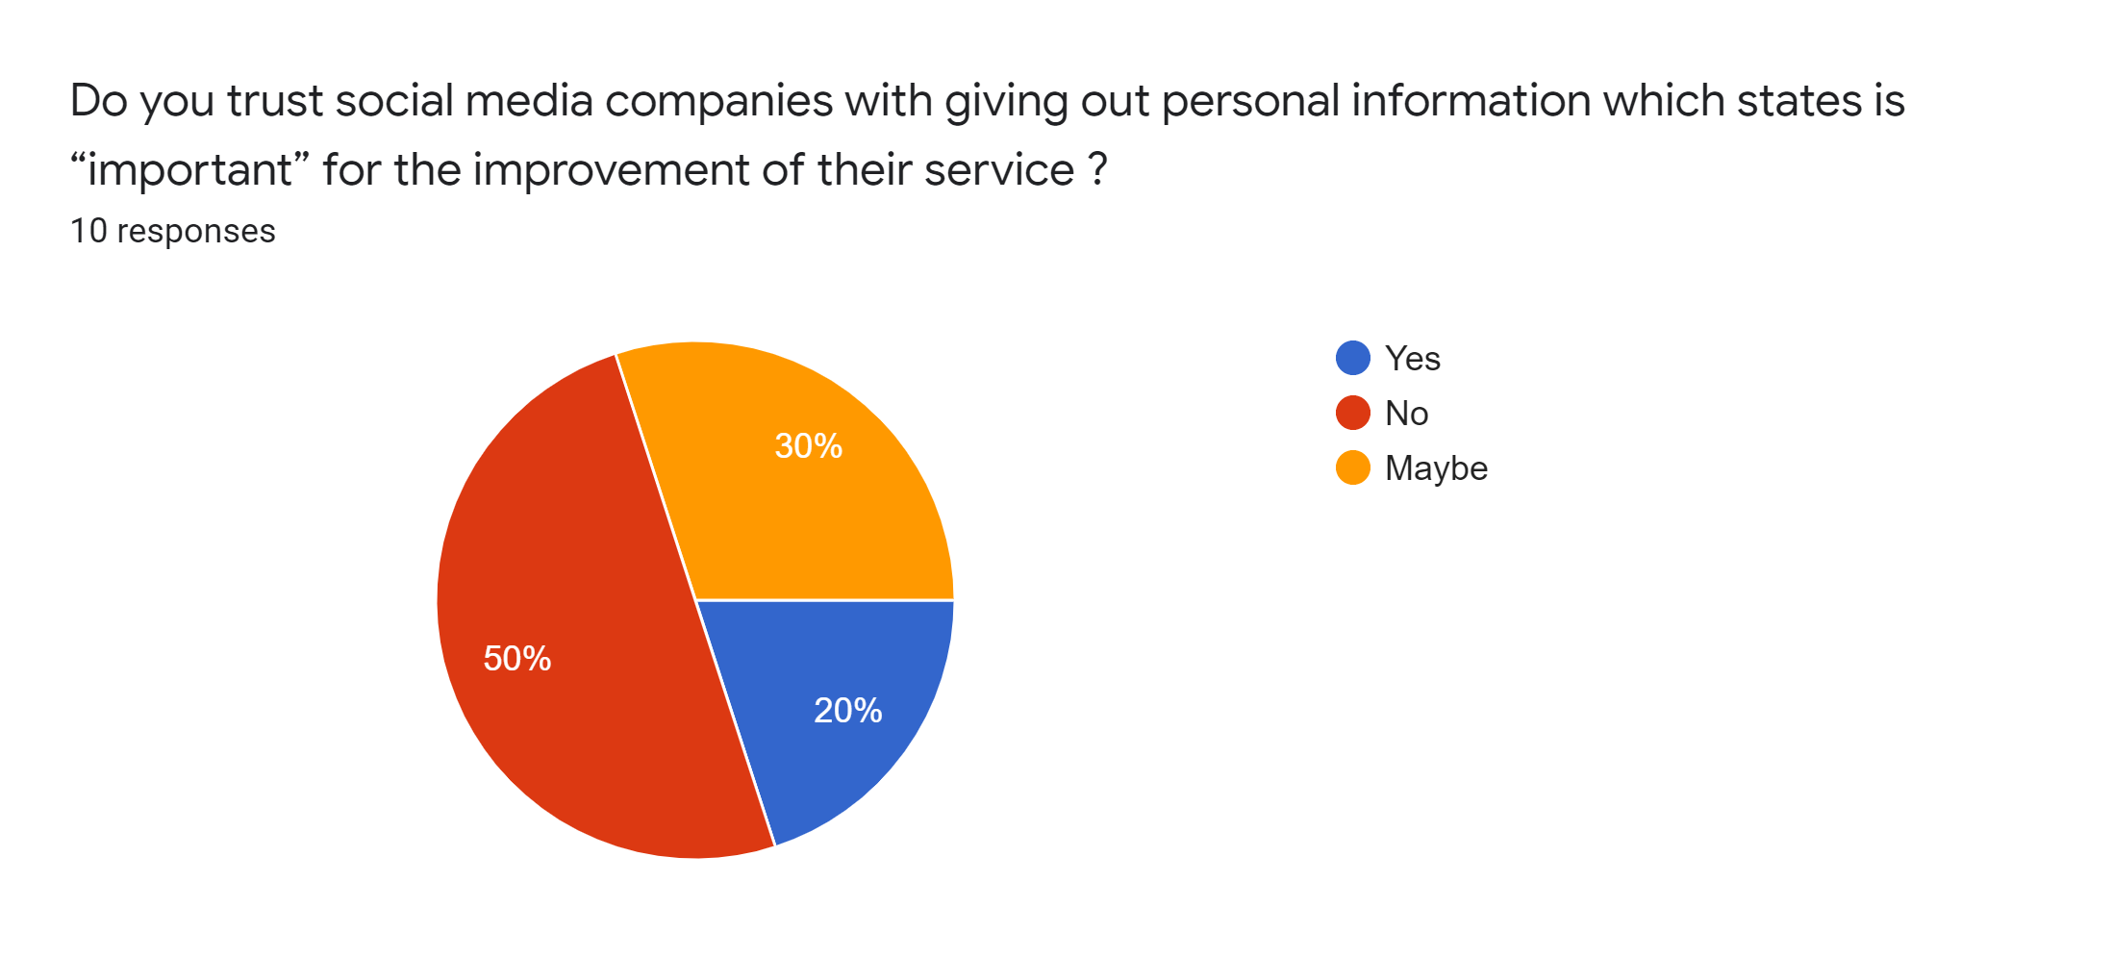

**Making a fresh starting -**

The best way to stay away from all of the unnecessary lure that the media tries to influence the public is by disconnection from the loop itself for the greater good of one's health. It may be difficult at first because things don’t stop you from living life the way it’s meant to be and refreshes your mind from all the impure and toxic environment that once corrupted the minds with a fresh new start in life.

**Recommended actions based on my secondary research -**

Here are a few recommended actions based on my secondary research and what possible methods that can be used to be adopted to improve it to be more effective in understanding the issue.

**Secondary research -**

The statistics below from the internet shows the number of users in different age groups and how much time users have spent on their devices for the year 2019

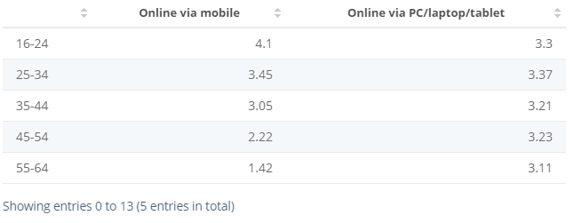

**Digital wellbeing communities -**

While going the secondary researches have found online community groups that take mental health seriously and offer help to those who struggle with digital wellbeing. These groups understand what it is like to face difficulties and come together with a solution that benefits everyone.

The statistics below from the internet shows the number of users in different age groups and how many users have access to devices for the year 2019

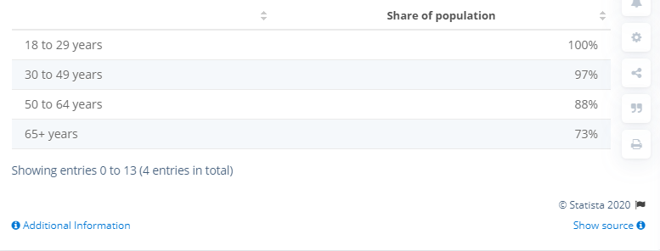

**Taking responsibility for health -**

It may be difficult at first but by taking responsibility for what Is done over social media and what is exposed to once mental health can help avoid any mental health issues caused by devices and digital media. It may sound simple but this is an effective way of preventing any sort of problems which starts off small and gradually develops into a more massive condition.

The statistics below from the internet shows the number of users in different age groups and how much time users have spent on their devices for the year 2019



**Online health programs -**

There are programs that are held for individuals that suffer mental health conditions through online health programs which help them take control over their mental wellbeing. It may give them a relief from any online abuse they may have been through and gives them a peace of mind.

The statistics below from the internet show the number of users in different age groups about if users trust social media applications with their personal information for the year 2020.

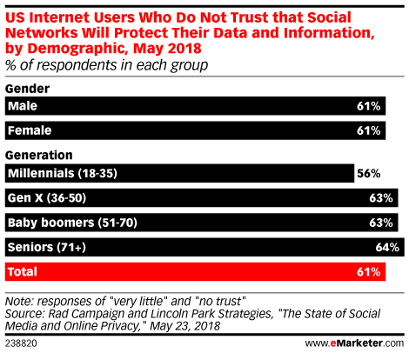

**Mental health groups -**

There are groups that are created for anyone who is undergoing mental health issues. A small group gets together to discuss with each other for solutions to their conditions they are facing and making each other feel better about themself. These groups help alleviate any pressure and stress caused by others online by taking performing stress relieving exercises and meditations in a secluded environment away from any digital media or devices.

The statistics below from the internet show the number of users in different age groups and how devices affect user’s daily tasks for the year 2020.

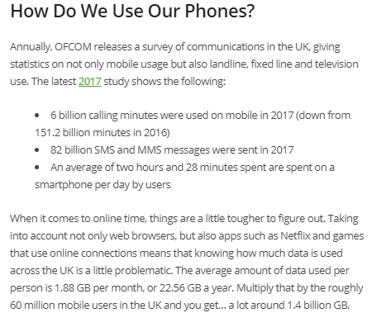

**Google’s Digital Wellbeing programme -**

Members of Google’s UX and product teams have implemented learnings about digital wellbeing and how to develop for it. It gives an insight into tools Google has built to help kids, adults, and families manage their relationships with technology. It also gains insight into how users feel about their technology use, how Google is promoting digital wellbeing, and how to embrace digital wellbeing values (awareness, control, value, trust) for better customer satisfaction.

**Taking a break -**

The simplest way to get away from technology that can distract us from our daily tasks is by taking a break from devices and social media by making an effort to lock it behind an obstacle to make it difficult to access and finding a reason to stop using and only used when necessary. By taking proper measures in reducing the usage of devices and online activity can make a difference in the quality of one's mental health and having control of what is exposed to the mind and removing negative energy from the body.

The statistics below from the internet shows the number of users in different age groups and how much time users have spent on their devices for the year 2019

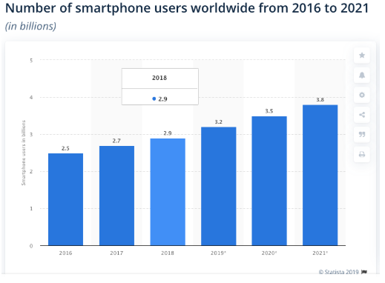

**Evidence of recommended actions based on from Secondary research -**

**Increase digital wellbeing health -**

The recommendation I would give based on the above primary and secondary research performed would be that digital wellbeing is growing more and more as users spend more time on their devices and seek for help to stay in control of their health.

**Safety Precautions -**

Users should stay in control by implementing strict rules to follow to reduce the amount they spend on devices and find other things to distract them from their addictions and find new hobbies that they like.

**Change in lifestyle -**

Taking a break would greatly improve their lifestyle and motivate them to go outside and make meaningful relationships and conversations which would otherwise not be possible.

**Making a schedule and changing habits -**

Users must take the first step in making a change in their daily habits by joining groups that move away from digital distractions and find other ways to interact with people.

**Objectives That I have met -**

**1. Carrying out secondary research using -**

**Other population demographics collected by municipal,**

These are data collected by the government which are archived in public libraries, books, etc. which provide with all the research data and events that took place over the years. This is the most convenient of research that is used to gather data for research which are filled with hundreds of books with research articles, documentations, journals, newspapers that are preserved from the past to be analysed. They also have huge collections of selections from different publishers and authors for the public to use.

**Provincial or federal government agencies**

These are data archives from the country's economy, sales, profits, losses, and income rates, etc. over a period of time and they are not easily accessible to the public for legal reasons.

**Reports issued by research institutions**

These research data are conducted by research institutes that have collected data using primary research methods and have documented these in reports that they have prepared by these research institutions.

**News reports**

These reports are from news outlets that collect information for the news media. They prepare reports which summarise data that they required for the media and document them in news articles for the public.

**Academic journals**

Academic journals have data that have been recorded by researchers in the past so that it can be documented to future generations to observe. These are literature books, historical journals, scriptures, etc. which help us to learn about the past.

**Newsletters**

Newsletters are short articles that are published in public communities that document and record data from their events and daily activities held over time. These are documented by schools, libraries, institutions, universities, etc. for preservation of information and for research purposes.

**Magazines and newspapers**

These are secondary research materials that assist researchers that have the necessary resources to perform primary research and look for data that have been recorded in magazines and newspapers for their research.

**Pamphlets**

These are small booklets that have brief information on a particular topic and have sections describing them in paragrams which is useful for a quick read into the topic of interest. They help provide information that gives an insight with data that has been collected.

**2. Carry out primary research by -**

**Interviews (telephone or face-to-face)**

Interviews are a way for collecting information directly by interacting with the participants. It makes it easier to express the feeling of the participants with no limitations from restriction and lets the participant branch out to provide more than what is expected.

**Surveys (online or mail)**

Surveys help collect data which can spread across a wider audience and help gather as much information without having to travel to places. They are quick and make collecting data more reliable and efficient when there is no time to go out and do it themselves.

**Questionnaires (online or mail)**

These are online forms which are sent by email or post to participants in different places. They are quick and easy to follow and are one of the primary research methods that can be used to collect data.

**Focus groups.**

Focus groups are groups that mainly focused on collecting data for research. They focus on collecting data using primary research methods to gather data from the public. These groups make it easier for researchers to focus more on their work than to collect data.

**Visits to company’s locations.**

By taking a visit to the company’s location to conduct research will help gather information first hand without having to go through documentations and resources that would take a long time to go through. It gives the researcher information that they would have not found anywhere as it may be limited or exclusive to the company itself.

**3. Compare the two research together and take points from each other.**

Comparing primary research with secondary research so that reasonable assumptions can be made about what the society thinks and feels about certain topics and matters they would view them. It makes the research more clear and gives a perspective of them for further research.

**4. Draw conclusions and make recommendations.**

After the data is collected and the primary and secondary research data is compared the next step is to make reasonable conclusions by making a report and drawing their main points and highlighting them with sufficient resources backing up the information that has been gathered. After finding resources to back up the data and drawing a conclusion a recommendation should be made about how to overcome the challenges that may be faced in going about the research and what could be done better in collecting data for primary and secondary research methods.

**Assistance that supported in completing my project -**

* All the resources were available online which helped me make progress in my project. Research made by others helped me compare my data with others and gave an overview of the topic that I have chosen.
* Material was made available by the teacher and guidelines were given to follow and keep track of the progress made with the help of project plan and deadlines to be met every week until the final deadline.
* Feedback was given after handing in the work which helped make changes and adding more content to the work.
* Class meetings were held every week discussing how to make progress on the project. Everyone was able to share ideas and thoughts in going about certain tasks and what was required to be achieved.
* Deadlines helped me get my work done on time and gave me a clear map on what task needed more attention to complete within the time limit. Spreading out the workload so that it was easier to focus on what task needed more priority than others.

**Obstacles that affected my progress in completing my project -**

* Due to recent events I faced challenging times and had a few weeks tough on me. The recent outbreak has affected most of the businesses and institutions which has led to closure of many small and large shops, companies, and even airports. Though this did not affect my progress massively I’ve managed to get work done on time and handed into the classroom.
* My work schedule has also made it challenging to manage work and assignments to be handed on time. With quick feedback and motivated help of the teacher it has been easier to get as much work done as possible before the deadline.
* Resources took a little longer to gather as it was difficult to go about conducting primary research due to the recent pandemic lockdown making it difficult to collect data physically and had to only rely on online forms and questionnaires that I had prepared for my research.

**Reasons for choosing this research project -**

* Reasons for choosing the project which were linked to other subjects that i was studying, I also had a personal interest in this field of research which helped me get motivated in proceeding with the research as future plans that include gaining knowledge and skills to improve my understanding of the topic as it is important to make a reasonable conclusion based on the research that I have collected.
* As I’m part of learning how tech works and how technology companies produce new software, I’m interested in how technology companies are responsible for the health, safety and wellbeing of their users.
* By performing research and finding out more about how others view the topic I have selected gives me an idea on how I can make the future better for others with the data that I have gathered to make those changes.
* The data that I collect may someday become useful to me in my career. With this research material I will be able to make a decision on what the demographic wants and requires and how it affects them in their daily life.
* The research data that i have collected will turn out to help someone that may need it for their research. This will prove useful to them in giving them an insight on this topic of research.

**Skills that I have gain after my research is completed-**

* A Deeper understanding of research methodologies
* Presentation skills
* Report writing skills
* Planning
* Time management
* Collection of data
* Analysis and evaluation of data
* Gathering data from secondary resources

**Final thoughts and views on the success of my Research -**

This research really helped build my knowledge and changed my perspective on how others perceive ideas and thoughts. It has personally developed my understanding on how technology has changed the way how people interact with each other and how it affects the way we go on with our daily lives.

With the resources I have used and collected using primary research and secondary research methods in gathering as much data possible has given me the ability to and skills to continue further and help me in my career moving forward.

I would like to thank my teacher Mrs Kam for providing me with all the resources that have been provided to me for helping me work on my research project and also people who have participated in providing data to further the progress on the success of my research.

**Conclusion -**

In conclusion, this report demonstrates reflection and engagement in the resource process leading to recommended actions for future improvement of the project outcomes. It also reflects on the success of the research project and the performance at the end of the project with the inclusion of a project evaluation and recommendations.

**Resources -**

Ons.gov.uk. 2020. *Young People Spend A Third Of Their Leisure Time On Devices - Office For National Statistics*. [online] Available at: <https://www.ons.gov.uk/peoplepopulationandcommunity/leisureandtourism/articles/youngpeoplespendathirdoftheirleisuretimeondevices/2017-12-19> [Accessed 20 March 2020].

Statista. 2020. *U.S. Internet Reach By Age Group 2019 | Statista*. [online] Available at: <https://www.statista.com/statistics/266587/percentage-of-internet-users-by-age-groups-in-the-us/> [Accessed 20 March 2020].

Statista. 2020. *Daily Internet Usage By Age And Device 2019 | Statista*. [online] Available at: <https://www.statista.com/statistics/416850/average-duration-of-internet-use-age-device/> [Accessed 20 March 2020].

Tech Jobs. 2020. *29+ Smartphone Usage Statistics: Around The World In 2020*. [online] Available at: <https://leftronic.com/smartphone-usage-statistics/> [Accessed 20 March 2020].

Limited, T., 2020. *Mobile Phone Usage Statistics In The UK: How Many Smartphone Users Are There - Tigermobiles.Com*. [online] TigerMobiles.com. Available at: <https://www.tigermobiles.com/blog/mobile-phone-usage-statistics/> [Accessed 20 March 2020].

Deloitte Insights. 2020. *To Share Or Not To Share*. [online] Available at: <https://www2.deloitte.com/us/en/insights/industry/retail-distribution/sharing-personal-information-consumer-privacy-concerns.html> [Accessed 20 March 2020].

BBC News. 2020. *'Only One In Four' Trust Social Media*. [online] Available at: <https://www.bbc.co.uk/news/business-42771740> [Accessed 20 March 2020].

eMarketer. 2020. *Trust Social Networks With Your Data? Nah. Use Social Anyway? Yep.*. [online] Available at: <https://www.emarketer.com/content/users-have-little-faith-in-social-networks-privacy-protections> [Accessed 20 March 2020].

Yougov.co.uk. 2020. *Social Media Content Is Often Unreliable, Say Users | Yougov*. [online] Available at: <https://yougov.co.uk/topics/technology/articles-reports/2019/10/31/social-media-content-often-unreliable-say-users> [Accessed 20 March 2020].

Lindsey, N., 2020. *Should Social Media Platforms Be Doing More To Win Back Online Trust?*. [online] CPO Magazine. Available at: <https://www.cpomagazine.com/data-privacy/should-social-media-platforms-be-doing-more-to-win-back-online-trust/> [Accessed 20 March 2020].

DigitalWellbeing.org. 2020. *Digital Wellbeing Statistics From Humane Tech Event*. [online] Available at: <https://digitalwellbeing.org/digital-wellbeing-statistics-from-humane-tech-event/> [Accessed 21 March 2020].